Requirement Analysis
Technology Stack (Architecture & Stack)
Date | 2 September 2026
Student Name | Naga Prathyusha Gujjula
Project Name | Employee Raise Issue
Maximum Marks

Technical Architecture
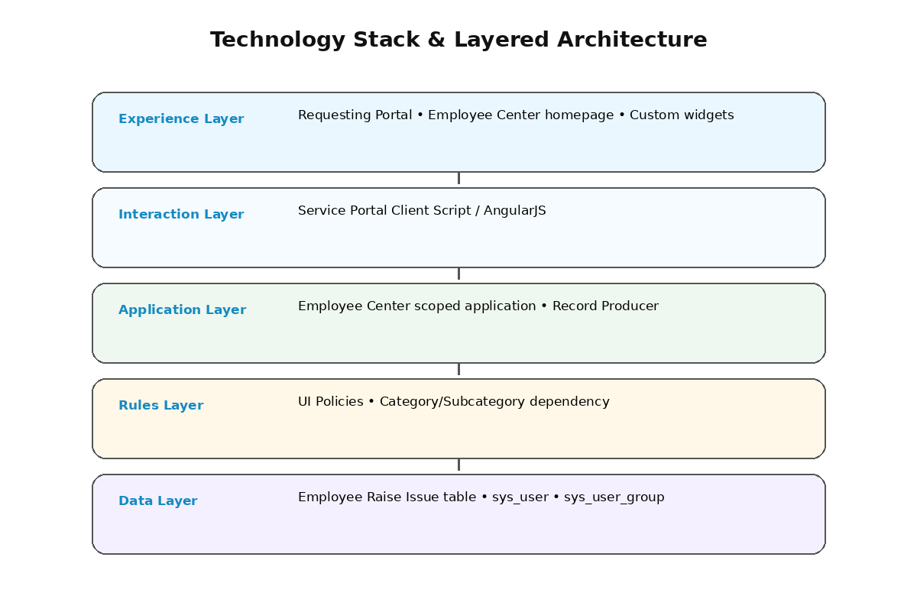
Figure 1: Layered technology architecture for the ServiceNow solution.
S.No. | Component | Description | Technology
1 | User Interface | Employee-facing portal and homepage. | Service Portal / Employee Center
2 | Application Logic | Application and guided issue submission. | ServiceNow Scoped Application / Record Producer
3 | Rules | Field validation and dependent choices. | UI Policies / Dictionary dependency
4 | Data | Issue persistence and references. | Employee Raise Issue / sys_user / sys_user_group
5 | Widgets | Custom presentation and navigation. | HTML / CSS / Client Script
6 | Client Logic | Redirect from widget to Record Producer. | Service Portal Client Script / AngularJS

